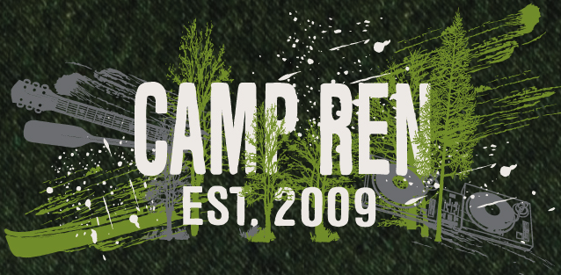

Name:_____________________________________
Please rate how much you like each activity area by circling the corresponding number.
(1 being you like the least, 5 what you like the most)

Science: Rocketry, Robotics, Forensics, Creative Cooking, Alternative Energy, Bridge Building

1 2 3 4 5

Visual Art: Ceramics, Drawing, Calligraphy, Glasswork, Painting, Jewelry Making, Art Show

1 2 3 4 5

Outdoor Adventure: Hiking, Survival Skills, Camping Skills, Gardening, Geocaching, Outdoor Cooking
1 2 3 4 5

Performing Arts: Improv, Acting, Dancing, Singing, Performing Plays, Talent Show, Music

1 2 3 4 5

Film: Music Videos, Camera Work, Editing, Short Films, Stop Motion Films

1 2 3 4 5

Athletics: Soccer, Tennis, Swim, Basketball, Volleyball, etc.

1 2 3 4 5

Other Activities: ______________________________________________________________

